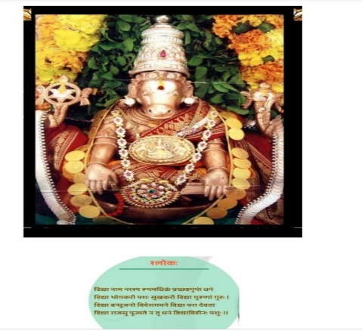

ज्ञानानन्द मयं देवं निर्मलस्फटिकाकृतिम् ।

आधारं सर्व विद्यानां हयग्रीवम् उपास्महे।। Hayagriva Stotra- Swami Desikan

**PANCHANGA-Article-2:**

**By Dr.KV Krishnan**

**To start with, let us review the Five (5) Angas we saw in the last Article.** They are **Vara, Titi, Nakshatra, Yoga and Karana**. Panca-Angas are essential to individuals as they help one to understand “**the** **quality of time”** (i.e., time one can choose to execute any **Karma** as dictated by Shastra). We will **understand** as we proceed further that Numbers 3,5,7,9, etc wherever they come in Vedic Grantas, like Jyotisha are related to specific Tatva as per Sanatana Dharma and are not random.

For example,

The Number (3) is connected to three Gunas**, namely Satva, Rajas and Tamas.**

The Number (5) is connected to five Butas**, Akasa, Vayu, Agini, Jalam and Prutvi**.

Astrologers know the importance of these two numbers 3 and 5, as it is discussed in detail in “The study of Astrology”.

As **our Guruji Sri. Dr. N.V.R.A Raja** keeps stressing in every one of his lectures **three Gunas (Satva, Rajas, and Tamas)** are going to be **the** primary factor based on which the Nakshatra Siddhanta Astrology, will develop further in future, though presently also Guruji has used it extensively in timing of events.

Pancha-Butas are connected to Rasis, and as Astrologers know Aries, Taurus, Gemini and Cancer are connected to Agni, Earth, Vayu-Air and Jalam-Water respectively. Ju (Guru or Brahaspati) the Aakasa lord pervades the entire twelve Rasis. Aakasa holds the Universe together. It is the binding glue which gives life, support and meaning (just like a Guru and his student).

**See below Panca-Angas and corresponding Panca-Butas**

**Panca-Anga Panca-Butas** Vara Agni

Titi Jala

Nakshatra Vayu

Yoga Akasa

Karana Prutvi (Earth)

**Study of quality of time: What is time and how do we understand it?**

All of us experience time with the help of light irrespective of the status of our vision. The main source of light for us is the Sun which is strong, bright, white and dominant in the sky. Moon, on the other hand filters the light taken from the Sun and reflects (passes) it to earth (us) during the night, which is soft, cool, and whitish in colour. This is called, **Sun and Moon energies**. It is from these two energies that the Panca-Angas **are derived.** Thus, time is a derivation, based on Sun and Moon’s position in the Sky and their energies, experienced by us.

**Time or Light quality is studied in different ways. We will consider the below approach:**

**1.Vara: Seven days** (Week Day), the **Agni Tatva**, Sun (Surya) dominating the entire day from Sun rise to Sun set and not allowing any other stars to shine. The week day order as we know is called **Vara** and it involves **Seven grahas**, Sun, Moon, Mars, Mercury, Jupiter, Venus, and Saturn. In day – day language it is referred to as Sunday, Monday, Tuesday, Wednesday, Thursday, Friday and Saturday. Due to the dominating nature of Sun, (the Agni Tatva of the week days) it is the over-all ruler of the week days – Vara. (**Sun -Surya-Agni).** No other Graha has any say during the Vara. It is only with the help of Agni we **can** reach any **Devata**. Therefore, all Yaga, Yagjnas are done in the presence of Agni and in older days people used to continuously keep it burning in their houses. Sun or Agni is also the creator, the Shrushti-karta as per scriptures, and considered as Eye of the Kalapurusha asper Purusha sukta and other Vedic hymns. Hence it is considered a very important Buta.

**2. Titi:** This is next time element. With the help of Mathematics, titi is calculated as the difference between the locations of Sun and Moon in the sky, (measurement in degrees). Since Moon keeps moving away and towards the Sun (also known as Sukla Paksham and Krishna Paksham or Bright half and Dark half), Titi is 30 in numbers fifteen in Sukla Paksha and fifteen in Krishna Paksha.

Moon keeps moving away from the Sun increasing its brightness along the way**.** At the time when Moon shines its maximum brightness it is known as Full-Moon Day OR Poornima OR Bright Moon Day**.** This bright Moon **comes once every 30 days.** (We call this Poornima to Poornima. The Moon’s movement away from or towards the Sun signifies 15 Titis - one titi per day **during** Moon’s **travel.**

Again, after full Moon Day, Moon starts to move towards Sun and loses its shine; this is when depression starts. **Once it** joins with the Sun it is called Dark Moon, or New Moon or Amavasya Day. Therefore, 15 + 15 = 30 Lunar day cycle **also known as** Moon Day cycle. **During this time** Moon would have travelled 360 degrees in these 30 days. Therefore, in each day the difference in location between Sun and Moon is 360/30=12 Degrees which is 1 titi.

The Sun and Moon when they come together at **“0 degrees”** it is called **New Moon** and when they are apart from each other at **“180 degrees”** it is called **full Moon.** Therefore, in Sukla Paksham Moon travels 180 deg and in Krishna paksham again 180 Deg. At Poornima the distance between Sun and Moon is 180 Deg and at Amavasya the distance is “0” deg.

Each day is a **Jala Day** and from the **table above** **we learnt that** Tatva for Cancer ruled by Moon is Jala Tatva. Thus, **Moon becomes the overall ruler of the Titi.**

Thus, two principal elements fire and water (Agni and Jalam) rules Vara and Titi.

**We will see briefly about Nakshatra, Yoga and Karana followed by details of Panca-Anga in the future issues of the magazine**